Collaboration Process

This diagram shows a lightweight approach to intentional collaboration. To anyone who has been in a group problem-solving session, some of the steps will look familiar, but it is common for groups to skip steps, lose track of the topic or otherwise become bogged down. The simple, iterative process I’ve outlined here includes somewhat less restrictive control points, with key highlights described below.

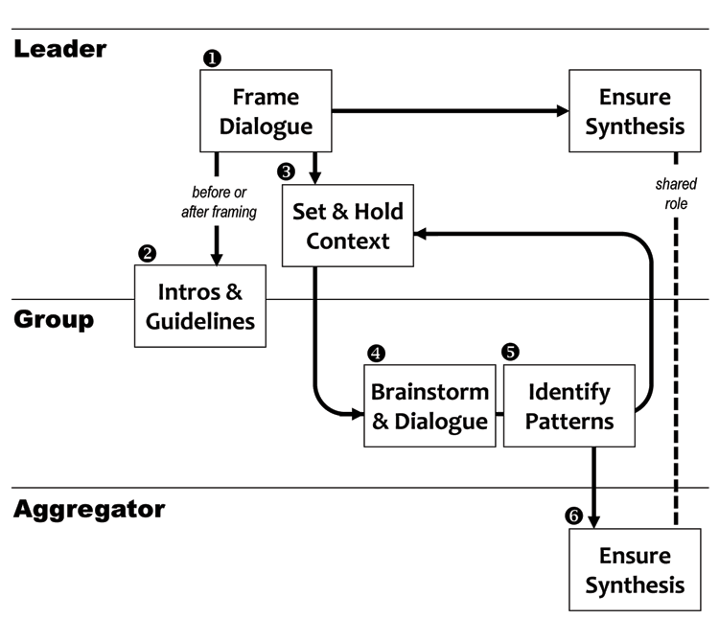
FIGURE 21 – Basic Collaborative Process as a Flow, p. 185.

LEADER (MODERATOR, PLANNER, REFEREE)
- Frame Dialog. Establish objective for the collaborative exercise, and resolve important semantics.
- Introductions and Guidelines. Identify potential relevance for participants, and begin building critical participant relationships. Can we establish some common ground? Can we establish nominal levels of Trust? What does success look like for this exercise? Introduce notions of “Loop Back” and “Key Roles” if applicable.
- Set and Hold Context. Establish initial context for the discussion, including focus, scope, and scenarios being considered, but allow opportunity for subsequent context changes after some discussion (see step 5, below).
GROUP (all Participate)
- Brainstorm and Dialogue. Review problem and offer solutions. Seek to balance input across group so that no one dominates. Encourage offline interaction among members if it is not disruptive to the overall flow.
- Identify Patterns (and “Loop Back”). Examine feedback received for relationships among concepts, new thinking, and any breakthrough insights. Consider modification of discussion context that might yield new insight (loop back to 3). The loop back step represents a critical change in traditional linear facilitation models, where changes to context are often discouraged. The ability of a group to navigate context change depends on careful coordination and communication between the MODERATOR and the full Group, to ensure everyone understands the reason for the shift. Roles like CONNECTOR, CHALLENGER and CATALYST are often responsible for triggering changes at this important stage in the collaboration.
AGGREGATOR (with help from full Group)
- Ensure Synthesis. Capture takeaways, making sure all useful insights are logged and that group has access to the full inventory; in this way collaborative outcomes become inputs to subsequent collaborations (another useful loop). This step is often skipped or incomplete, greatly diminishing the productive value (tangible, actionable outcomes) of the collaborative exercise.

