2013 CBODN Conference
April 26, 2013

Coaching for Change, Higher Consciousness & Courage in Complex Environments
Aman Gohal and Judy Tso, Booz Allen Hamilton

Definitions of Courage:

- The quality of mind or spirit that enables a person to face difficulty, danger, pain
- Middle English corage, from Anglo-French curage, from quer, coer heart, from Latin cor— more at heart
- The word courage had a very different definition than it does today. Courage originally meant “To speak one’s mind by telling all one’s heart.”

T.E.D. (The Empowerment Dynamic)
- See separate handout

Tiger symbolizes confidence, confidence to be in the moment, to know just what to do, what amount of effort is necessary. The tiger does not fear, does not overthink.
The mind of the tiger is humble, free from arrogance. It looks before it leaps, and whatever it is doing, it is completely engaged. This quality of meekness connects it with the earth. Here in the West, we associate weakness with meekness. The Tibetan word for meek also means “content.” The tiger’s contentment comes from knowing that everything it needs is contained in the present moment.
-Ruling Your World by Sakyong Mipham

Concept of Confidence:

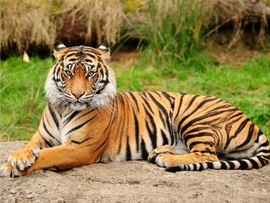

Concept of Basic Goodness:

"If we are willing to take an unbiased look, we will find that, in spite of all our problems and confusion, all our emotional and psychological ups and downs, there is something basically good about our existence as human beings. We have moments of basic non-aggression and freshness...it is worthwhile to take advantage of these moments...we have an actual connection to reality that can wake us up and make us feel basically, fundamentally good… The realization that we can directly experience and work with reality." Sakyong Mipham

